**2024 Survey Results**

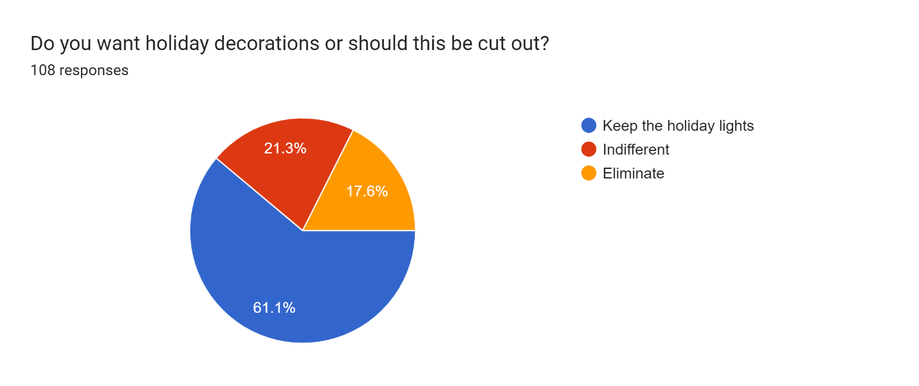

Add anything or cut? (Top answers)

No, current is good, same - 25

Cut the bows - 12

Forms response chart. Question title: Do you want mosquito spraying or should it be eliminated?
. Number of responses: 111 responses.

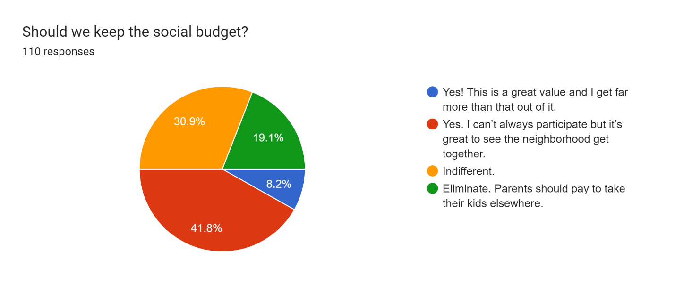

Yard of the Month

Forms response chart. Question title: Should we keep doing this program?
. Number of responses: 111 responses.

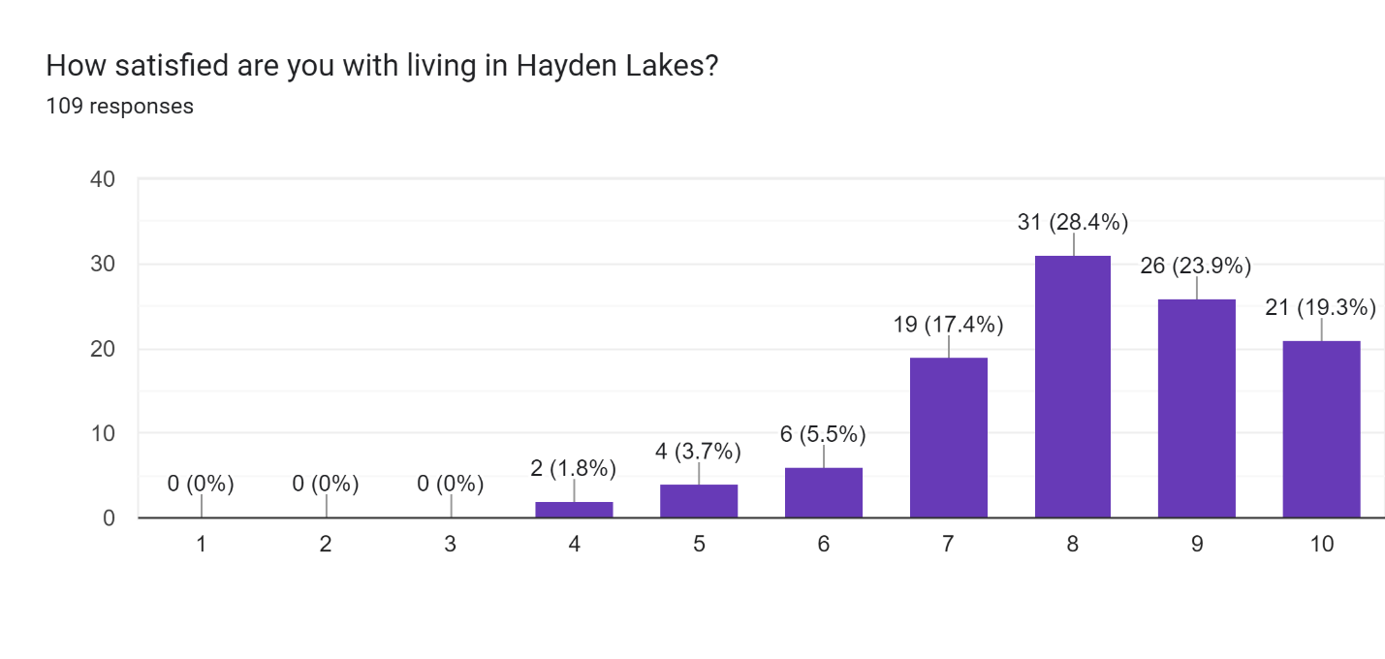

Like Most

Neighbors, close-knit - 20

Green space, lakes, walking trails - 27

Appearance, landscaping – 20

Top Concerns

Increasing dues – 13​

Homeowner yard upkeep – 11​

Cars parked in the street – 9​

Landscaping/dead trees – 8​

